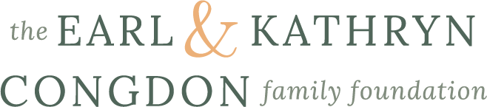

Capacity Building Grant Application
2024

The Congdon Foundation developed the Capacity Building Grants Program to address a common desire among our partner nonprofits to do more, to do better, and to be sustainable.
The Capacity Building Grants are intended to fund efforts like: adding staff, expanding facilities, building out digital infrastructure, enlisting consultants or other professionals, enhancing fundraising or marketing efforts, creating programs, and developing leadership.
As a family rooted in High Point, NC, the grantmaking work of the foundation is restricted to 501(c)3, public charity nonprofits in the Greater High Point area, unless your nonprofit was invited to apply by a member of the Capacity Building Grants Board.

- The annual Capacity Building Grant cycle runs from January 1st – January 31st. Decisions are announced by the end of March with funds made available in April.
- Each grant will be for $30,000 and renewable for three years. Thus, each grantee will get a total of $90,000 over the course of the grant, assuming positive annual reviews, which are based on conversations with foundation staff.
- Each year, the Congdon Foundation will award ten new Capacity Building Grants.
- The application process is online, short, and focused on how funds will be used to create capacity.
- Each year the Capacity Building Grant call for proposals focuses on a different one of the foundation’s three funding priorities: Education (2024), Critical Community Needs (2025), and Economic Development (2026).
- Contact Dr. Joe Blosser, Chief Impact Officer, if you have questions: joe@congdonfoundation.org.

See the application questions below.

Application Questions

Organizational Information
- Tax ID/EIN
- Organizational Name
- Fiscal Sponsor Name, if applicable
- Address, City, State, Zip Code
- Website, if available
- Describe the organization and its mission (i.e., what do you do?) 500 characters

Primary Contact Information
- First Name, Last Name, Title, Phone, Email

Executive (if different from Primary Contact)
- First Name, Last Name, Title, Phone, Email

General Financial Information
- What is your fiscal year? Example July 1-June 30 or Calendar Year
- Total Current Year Annual Budget

Grant Request
- What is the name of this grant request?
- What is the total budget for the proposed capacity building project? The grant will be for $30,000 a year for three years. This is asking for the budget of the capacity building project as a whole, which might just be $30,000 a year, depending on your goals.
- Describe the geographic area the grant will serve.
- How will the funds be used each year to build capacity in the organization? 500 characters

Grant Evaluation - All 1,000 characters
- What is going on in the community where you work, and how is your organization leading or partnering in efforts that build on existing resources to produce positive outcomes?
- What is the expected impact of this grant on the organization? That is, how will the organization be better equipped to achieve its mission after this three year grant?
- How will you know if this grant is a success? That is, what are the metrics, stories, or other measures of impact that will show you that the capacity of the organization has been successfully built?
- Who are the relevant staff, volunteers, and/or partner organizations that will collaborate on this grant? Provide brief descriptions of the roles they will play.
- How will you carry forward the work started under this grant once the three years are over?

Attachments – All PDFs
- List of Board of Directors, Current Annual Year Budget, Last three years of financials (if available), Last 990, Last audit (not required)

